Question Bank CG

[other subjects ans. click](https://github.com/neeraj46665/BTech-CS-Notes/tree/main/BTech-2nd-year/sem-4)

1. Illustrate the different types of Computer Graphics.

The computer graphics contains two types. They are-

* **Raster (Bitmap) graphics**
* **Vector graphics**

**Raster (Bitmap) Graphics**

You are probably familiar with raster graphics if you have ever captured or downloaded a digital picture; even if you're not conscious, this is what digital pictures are.

By considering the graphics field as a rectangle shape and separating the rectangle into some kind of two-dimensional array of small pixels, a raster represents an image.

**Benefits of Raster (Bitmap) Graphics**

* It is simple to construct raster files through existing pixel information stored in a sequence in memory space.
* It is also possible to retrieve pixel information stored in a raster file while using a collection of coordinates that enables the information to be characterized in the grid form.
* If available, pixel values can be changed separately or as huge sets by changing a gradient.
* Raster graphics can transform well to external devices like CRTs and printers in spot-format.

**Vector graphics**

The optimal key to build a digital picture is to compile a list of commands that explain how to depict the picture and then save the list as an image file. The machine perceives each command and redraws the full image while the file is opened, normally as a bitmap for demonstration purposes. This mechanism is called rasterization.

This can seem to be an overly complicated approach for a graphical picture to be produced. There are several specifications for vector graphics, and some of those (– for example, AI, CDR) are patented. SVG (Scalable Vector Graphics) is one more open vector graphics standard that becomes incredibly famous. A Vector format file can be accessed by opening it with a text editor (like Notepad) software.

Nowadays, vector images are usually placed in graphical file formats like SVG, EPS, PDF, or AI, which are inherently distinct from the more traditional raster image formats such as JPEG, PNG, APNG, GIF, and MPEG4.

**Benefits of Vector Graphics**

* Vector files are thin in size since they have less information than bitmap image files.
* Vector images are more versatile than bitmap graphics because the graphical fidelity can be increased up and down quickly without any loss.
* Vector image files have sharper lines compared to rectangular, pixel-based bitmap graphics, so they are stronger than raster images with straight lines and flowing curves.

**Drawbacks of Vector Graphics**

* When a vector image has minor defects, these are shown when the vector image is greatly expanded.
* A static color or gradient is usually loaded with vector images. Comprehensive picture (photo) attributes cannot be viewed as bitmap graphic

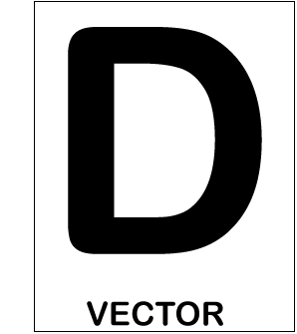 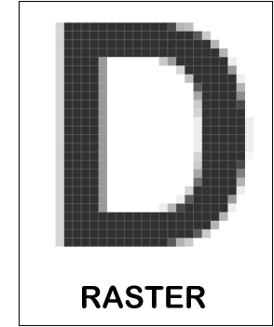

1. Explain Frame Buffer.

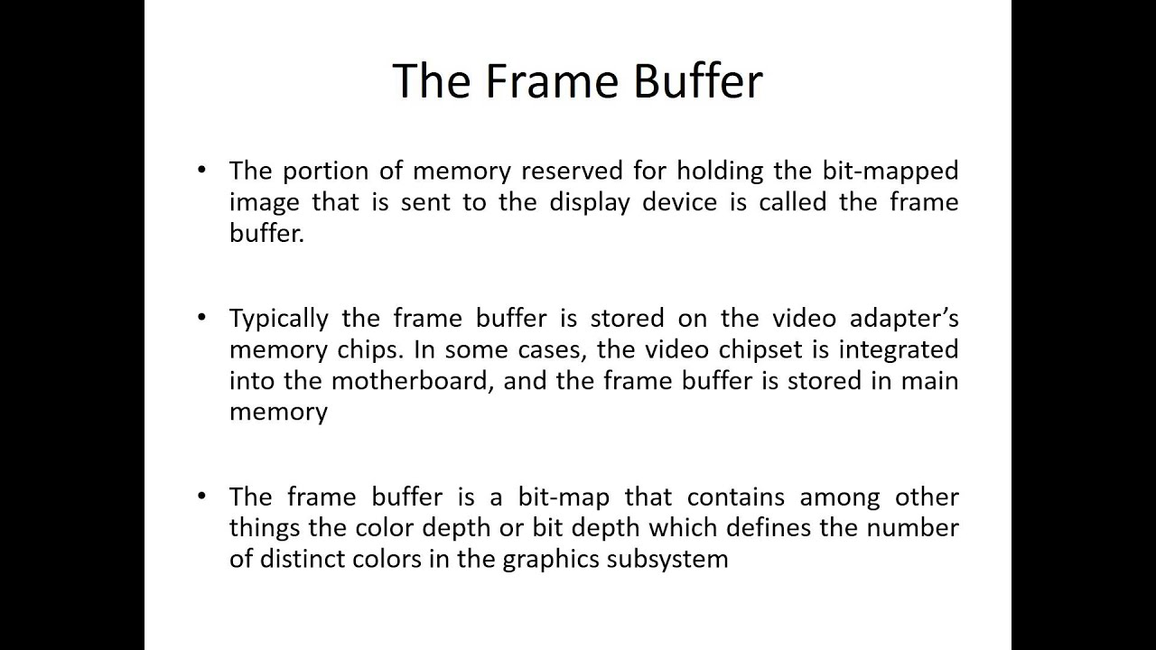

1. Explain DDA Line Drawing Algorithm and find the intermediate points of line having end points (2,2) and (9,7)

DDA stands for Digital Differential Analyzer. It is an incremental method of scan conversion of line. In this method calculation is performed at each step but by using results of previous steps.

1. Illustrate Refreshing, Refresh Rate and Critical Fusion Frequency in Display Devices.

b)

a higher refresh rate refers to the frequency that a display updates the onscreen image. The time between these updates is measured in milliseconds (ms), while the refresh rate of the display is measured in hertz (Hz).

The refresh rate of your display refers to how many times per second the display is able to draw a new image. This is measured in Hertz (Hz). For example, if your display has a refresh rate of 144Hz, it is refreshing the image 144 times per second. 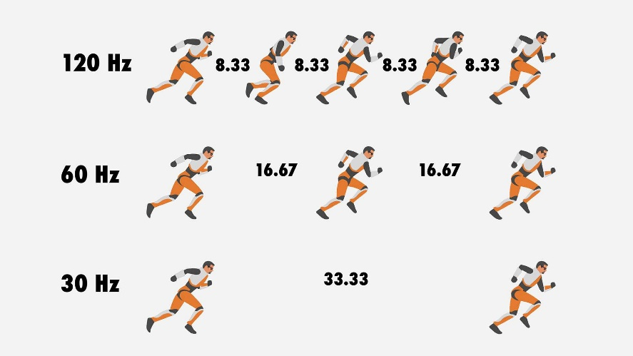

* 1. Refreshing is the transfer of data between two types of the same storage medium so there are no bitrate (the number of bits that are conveyed or processed per unit of time. ) changes or alteration of data.For example, transferring census data from an old preservation CD to a new one. This strategy may need to be combined with migration when the software or hardware required to read the data is no longer available or is unable to understand the format of the data.Refreshing will likely always be necessary due to the deterioration of physical media.

c) The critical fusion frequency, also known as flicker fusion threshold, is the frequency at which a flashing light source appears steady to the human eye. It refers to the highest refresh rate at which an individual can perceive a flicker or detect a discontinuity in the displayed image. The CFF varies among individuals but is generally around 60 Hz for most people.

If the refresh rate falls below the CFF, the human eye can detect flickering, which can cause eyestrain, headaches, or discomfort. This is more noticeable when viewing content with high contrast or rapid changes, such as scrolling text or fast-moving objects. To provide a flicker-free experience, display devices typically have a refresh rate higher than the CFF to ensure that the image appears smooth and continuous to the viewer.

It's worth noting that advancements in display technology, such as the introduction of OLED and high refresh rate displays, have significantly reduced flickering and improved visual comfort for users, even at lower brightness levels or lower refresh rates.

1. Illustrate how Random Scan System is different from Raster Scan System?

|  |  |  |
| --- | --- | --- |
| 1. Feature | Random Scan | Raster Scan |
| Refresh rate | Varies depending on the complexity of the image | 60 to 80 frames per second |
| Resolution | Lower | Higher |
| Cost | More expensive | Less expensive |
| Modifications | Easy to modify | Difficult to modify |
| Interlacing | Not used | Used |
| Image rendering | Uses mathematical functions | Uses pixels |
| Suitability | Suitable for applications requiring polygon drawings | Suitable for creating realistic images |

drive_spreadsheetExport to Sheets

Random scan systems use an electron beam to draw images on a screen. The beam is controlled by a computer, which can be used to draw any type of image, including lines, curves, and text. Random scan systems are often used in applications where it is important to be able to quickly and easily modify images, such as computer-aided design (CAD) and computer-aided manufacturing (CAM). However, random scan systems typically have lower resolution than raster scan systems.

Raster scan systems use a rectangular grid of pixels to display images. The pixels are turned on or off to create the image. Raster scan systems are typically used in applications where it is important to display realistic images, such as televisions and computer monitors. Raster scan systems have higher resolution than random scan systems, but they are also more expensive and difficult to modify.

In general, random scan systems are better suited for applications where it is important to be able to quickly and easily modify images, while raster scan systems are better suited for applications where it is important to display realistic images.

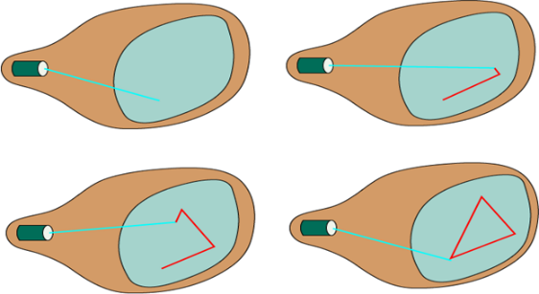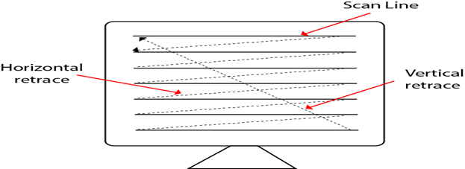

1. Discover and analyse the window to viewport normalization Transformation, that maps a window whose lower left corner is at (1,1) and upper right corner is at (3,5) onto a viewport that has lower left corner at (0,0) and upper right corner at (12,12).
2. Develop the mirror image of the triangle ABC about y=x axis with the help of matrices, using homogeneous coordinates.
3. Build the general form of the matrix for rotation about a point P(h, k).



* θ is the angle of rotation in radians
* h is the x-coordinate of the point P
* k is the y-coordinate of the point P

1. Explain Bresenham’s Line Drawing Algorithm and draw the line from (4,4) and (9,8).
2. Interpret the Scan Line Method for hidden surface removal in three dimensional objects.
3. Articulate about the 2 D Geometric Transformation in detail and apply 2D Transformation to build the Transformation Matrices and equations.

2D geometric transformation is a process of changing the position, size, or shape of an object in a two-dimensional plane. There are many different types of 2D geometric transformations, including translation, rotation, scaling, and shearing.

Translation is a transformation that moves an object from one location to another. The amount of movement is specified by a vector that has two components: the x-component specifies the amount of movement in the x-direction, and the y-component specifies the amount of movement in the y-direction.

Rotation is a transformation that rotates an object around a central point. The amount of rotation is specified by an angle. The angle can be positive or negative, and it specifies the direction of rotation.

Scaling is a transformation that changes the size of an object. The amount of scaling is specified by two numbers: the x-factor specifies the amount of scaling in the x-direction, and the y-factor specifies the amount of scaling in the y-direction.

Shear is a transformation that changes the shape of an object. The amount of shearing is specified by two numbers: the x-factor specifies the amount of shearing in the x-direction, and the y-factor specifies the amount of shearing in the y-direction.

2D geometric transformations can be applied to build transformation matrices and equations. A transformation matrix is a 2x2 matrix that is used to represent a transformation. The transformation matrix can be used to calculate the new coordinates of a point after it has been transformed. A transformation equation is an equation that can be used to calculate the new coordinates of a point after it has been transformed.

The following are some examples of how 2D geometric transformations can be applied to build transformation matrices and equations:

* Translation: The transformation matrix for translation is a 2x2 identity matrix with the translation vector added to the bottom row. The transformation equation for translation is (x, y) → (x + tx, y + ty).
* Rotation: The transformation matrix for rotation is a 2x2 rotation matrix. The rotation matrix is calculated using the angle of rotation. The transformation equation for rotation is (x, y) → (x cos(θ) - y sin(θ), x sin(θ) + y cos(θ)).
* Scaling: The transformation matrix for scaling is a 2x2 scaling matrix. The scaling matrix is calculated using the x-factor and the y-factor. The transformation equation for scaling is (x, y) → (x * x_factor, y * y_factor).
* Shear: The transformation matrix for shearing is a 2x2 shearing matrix. The shearing matrix is calculated using the x-factor and the y-factor. The transformation equation for shearing is (x, y) → (x + x_factor * y, y + y_factor * x).

1. List steps are required to plot a line whose slope is between 0 degree and 45 degree using Bresenham’s Algorithm?
2. Do you need to generate the full circumference of the circle using the algorithm, or can we generate it in a quadrant or octant only and then use it to produce the rest of the circumference?
3. Distinguish 3 D Object Primitives with their examples, Analyse the different methods, by which a polygon surface can be represented.

3D object primitives are basic shapes that can be used to create more complex 3D objects. Some common 3D object primitives include:

* Points: A point is a single location in 3D space.
* Lines: A line is a one-dimensional object that has a length and no width.
* Planes: A plane is a two-dimensional object that has a width and height, but no depth.
* Spheres: A sphere is a three-dimensional object that has a radius and no edges or corners.
* Cylinders: A cylinder is a three-dimensional object that has a radius and a height, and two circular bases.
* Cone: A cone is a three-dimensional object that has a circular base, a curved side, and a point at the top.
* Torus: A torus is a three-dimensional object that has a circular cross-section and is shaped like a donut.

These primitives can be used to create more complex 3D objects by combining them in different ways. For example, a cube can be created by combining six squares, and a pyramid can be created by combining four triangles.

There are different methods by which a polygon surface can be represented. Some common methods include:

* Polygon tables: A polygon table is a data structure that stores the vertices and edges of a polygon.
* Plane equations: A plane equation is an equation that describes the surface of a plane.
* Polygon meshes: A polygon mesh is a collection of polygons that are connected together.

Polygon tables are the simplest method for representing a polygon surface. However, they can be inefficient for storing large or complex polygons. Plane equations are more efficient than polygon tables, but they can be difficult to use for complex polygons. Polygon meshes are the most efficient method for storing and representing polygon surfaces. However, they can be more difficult to use than polygon tables or plane equations.

1. Explain Mid Point Circle Generation Algorithm. Generate points for one octant (90 to 45) with radius 7 unit.
2. Given a triangle with vertices (0,0), (2,0) and(1,1). Reflect this triangle about (a). x axis, (b). y axis (c). Line x=2 (d). y=1, and find the new vertices after reflection.
3. Draw a neat diagram for CRT(Cathode Ray Tube) and use it to analyse the different components of CRT and discover their functionalities in detail.

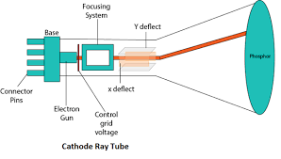

The different components of a CRT are:

* Electron gun: The electron gun is the source of the electron beam. It consists of a heater, cathode, grid, pre-accelerating anode, focusing anode and accelerating anode. The electrons are emitted from the cathode and are accelerated by the anodes.
* Beam deflection system: The beam deflection system is used to control the direction of the electron beam. It consists of two pairs of deflection plates, one pair for horizontal deflection and one pair for vertical deflection. The deflection plates create an electric field that deflects the electron beam.
* Phosphor screen: The phosphor screen is the surface on which the image is displayed. It is coated with a material that emits light when it is hit by electrons.
* Anode: The anode is the positive electrode in the CRT. It is used to accelerate the electron beam.
* Cathode: The cathode is the negative electrode in the CRT. It is used to emit electrons.
* Heater: The heater is used to heat the cathode. The heat causes the cathode to emit electrons.
* Control grid: The control grid is used to control the intensity of the electron beam. The grid is made of a fine wire mesh and is located between the cathode and the anode. The amount of current flowing through the grid controls the number of electrons that are emitted from the cathode.

The electron gun, beam deflection system, phosphor screen, anode, cathode, heater, and control grid all work together to create an image on the CRT screen.

The electron gun emits a beam of electrons that is accelerated by the anode. The beam deflection system then controls the direction of the electron beam so that it hits the phosphor screen at the correct location. The phosphor screen then emits light when it is hit by the electron beam. The light from the phosphor screen creates the image that is displayed on the CRT screen.

1. Justify the uses of A-buffer method and Scan line method
2. Apply Sutherland Hodgeman Polygon Clipping Algorithm to Clip the given polygon.

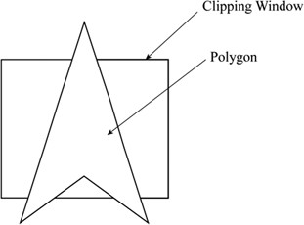

Develop the procedure for Window to Viewport Coordinates Transformation in 2D.

1. Classify different types of Polygon Tables and write advantages and disadvantages of each of them.

* Edge-based polygon tables: These tables store the edges of a polygon, along with their start and end points. This is the simplest type of polygon table, but it can be inefficient for storing large or complex polygons.
* Vertex-based polygon tables: These tables store the vertices of a polygon, along with their connectivity information. This is a more efficient way to store polygons than edge-based tables, but it can be more difficult to use.
* Hybrid polygon tables: These tables combine the features of edge-based and vertex-based tables. They store both the edges and vertices of a polygon, along with their connectivity information. This is the most efficient way to store polygons, but it can be the most difficult to use.

Here is a table that summarizes the advantages and disadvantages of each type of polygon table:

|  |  |  |
| --- | --- | --- |
| Type of Polygon Table | Advantages | Disadvantages |
| Edge-based | Simplest to implement | Inefficient for storing large or complex polygons |
| Vertex-based | More efficient than edge-based tables | More difficult to use |
| Hybrid | Most efficient way to store polygons | Most difficult to use |

drive_spreadsheetExport to Sheets

The best type of polygon table to use depends on the specific application. For example, edge-based tables may be the best choice for a simple 2D game, while hybrid tables may be the best choice for a complex 3D modeling application.

Here are some additional details about each type of polygon table:

* Edge-based polygon tables: Edge-based polygon tables are the simplest type of polygon table. They store the edges of a polygon, along with their start and end points. This is the most efficient way to store polygons if the number of edges is small. However, if the number of edges is large, edge-based tables can become inefficient.
* Vertex-based polygon tables: Vertex-based polygon tables store the vertices of a polygon, along with their connectivity information. This is a more efficient way to store polygons than edge-based tables, because it does not store duplicate edges. However, vertex-based tables can be more difficult to use, because they require the user to keep track of the connectivity information.
* Hybrid polygon tables: Hybrid polygon tables combine the features of edge-based and vertex-based tables. They store both the edges and vertices of a polygon, along with their connectivity information. This is the most efficient way to store polygons, because it does not store duplicate edges and it does not require the user to keep track of the connectivity information. However, hybrid tables can be the most difficult to use, because they require the user to manage both the edges and the vertices of a polygon.

1. At R be Rectangular window whose lower left head corner is at l(-3,1) and upper
2. Given a clipping window A(20, 20), B(60, 20), C(60, 40) and D(20, 40), apply Cohen Sutherland Line Clipping algorithm and solve to find the visible portion of the line segment joining the point P(40, 80) and Q(120, 30).
3. Write bresenham’s line drawing algorithm and trace the algorithm for the given points (2, 1) to (8, 6)
4. "Given a square with vertices A(0,0), B(1,0), C(1,1) and D(0,1). Shearing Factors Shx and Shy are 2 and 3 respectively. Apply 2D Shearing Transformation and find the new vertices of the square after shearing in-
   1. x direction only.
   2. y direction only.
   3. x and y directions both."
5. Apply Sutherland Hodgeman Polygon Clipping Algorithm to Clip the given polygon.

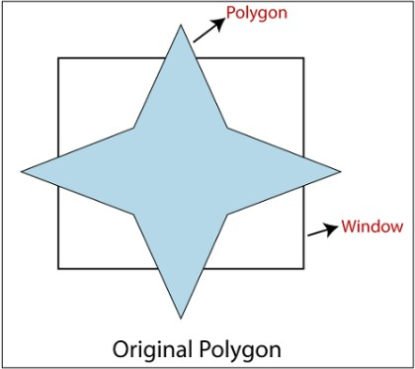

1. Calculate the pixel locations approximating the first octant of a circle having centre at (0,0) and radius 6 units.
2. Use Transformation matrices to carry out a 45 degree rotation of triangle A(0, 0), B(1, 1), C(5, 2) about P(-1, -1) followed by reflection w.r.t y axis
3. Compare Bresenham line generation with DDA line Generation.
4. Define the following term
5. parallel projection
6. Perspective projection
7. Projection reference point
8. vanishing point
9. orthographic parallel projection
10. orthographic oblique projection"

a) Parallel projection: In parallel projection, all lines of sight are parallel to each other. This means that all parallel lines in the real world will remain parallel in the projected image. Parallel projection is often used in technical drawings and architectural plans, because it provides a more accurate representation of the object than perspective projection.

b) Perspective projection: In perspective projection, the lines of sight converge at a single point called the vanishing point. This gives the illusion of depth, because objects that are closer to the viewer appear larger than objects that are further away. Perspective projection is often used in art and animation, because it creates a more realistic and engaging image.

c) Projection reference point: The projection reference point is the point in space from which the lines of sight in a projection are drawn. In parallel projection, the projection reference point is infinitely far away. In perspective projection, the projection reference point is located at the center of the image.

d) Vanishing point: A vanishing point is a point in a perspective projection where parallel lines appear to converge. Vanishing points are often used to create the illusion of depth in a drawing or image.

e) Orthographic parallel projection: An orthographic parallel projection is a type of parallel projection in which the lines of sight are perpendicular to the projection plane. This type of projection is often used in technical drawings and architectural plans, because it provides a more accurate representation of the object than other types of parallel projections.

f) Oblique orthographic projection: An oblique orthographic projection is a type of orthographic projection in which the lines of sight are not perpendicular to the projection plane. This type of projection is often used to create a more dynamic and interesting image than a traditional orthographic projection.

1. Compare and Contrast between Bezier and B Spline Curve. (K4)

|  |  |  |
| --- | --- | --- |
| Feature | Bezier Curve | B-Spline Curve |
| Degree | The degree of a Bezier curve is the same as the number of control points minus one. For example, a cubic Bezier curve has four control points. | The degree of a B-spline curve can be any number from one to the number of control points minus one. |
| Continuity | Bezier curves are C2 continuous, which means that they are smooth and have continuous curvature. | B-spline curves can be C0, C1, C2, or C3 continuous, depending on the type of spline. |
| Ease of Use | Bezier curves are relatively easy to use, because they can be defined using only control points. | B-spline curves can be more difficult to use, because they require the user to specify the knots and the basis functions. |
| Applications | Bezier curves are often used in computer graphics, because they are easy to use and can be used to create smooth curves. | B-spline curves are often used in computer-aided design (CAD), because they can be used to create complex curves and surfaces. |

In general, Bezier curves are easier to use than B-spline curves, but B-spline curves offer more flexibility and control. The best type of curve to use depends on the specific application.

Here are some additional details about Bezier curves and B-spline curves:

* Bezier curves: Bezier curves are defined using a set of control points. The curve is a smooth interpolation of the control points. The degree of a Bezier curve is the same as the number of control points minus one. For example, a cubic Bezier curve has four control points.
* B-spline curves: B-spline curves are defined using a set of control points, knots, and basis functions. The knots are points along the curve that define the start and end of each segment of the curve. The basis functions are mathematical functions that blend the control points together to create the curve. The degree of a B-spline curve can be any number from one to the number of control points minus one.

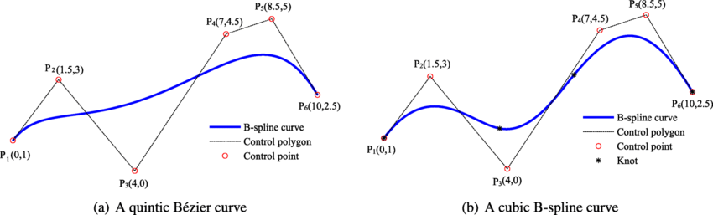

1. Explain the function of Control Grid in Cathode Ray Tube (CRT).

The control grid in a cathode ray tube (CRT) is a thin wire mesh that is located between the cathode and the anode. It is used to control the intensity of the electron beam. The amount of current flowing through the control grid determines the number of electrons that are emitted from the cathode.

When the control grid is negative, it repels electrons, which reduces the number of electrons that are emitted from the cathode. This results in a decrease in the intensity of the electron beam. When the control grid is positive, it attracts electrons, which increases the number of electrons that are emitted from the cathode. This results in an increase in the intensity of the electron beam.

The control grid is used to create the image on the CRT screen. The electron beam is scanned across the screen, and the intensity of the beam is varied depending on the image that is being displayed. This creates the illusion of a moving image on the screen.

The control grid is an important part of the CRT, and it is essential for creating the image on the screen.

Here are some additional details about the control grid:

* The control grid is made of a thin wire mesh, so that it has a very small capacitance to the cathode. This allows for a small change in voltage to cause a large change in the number of electrons emitted from the cathode.
* The control grid is located very close to the cathode, so that the electric field from the control grid can have a strong effect on the electrons emitted from the cathode.
* The control grid is usually held at a negative voltage with respect to the cathode. This is because electrons are negatively charged, and like charges repel each other.

1. Develop a procedure, based on a back-face detection technique, for identifying all the visible faces.
2. Explain Horizontal Retrace and Vertical Retrace.

Horizontal retrace and vertical retrace are two parts of the process of displaying an image on a cathode ray tube (CRT) monitor.

* Horizontal retrace: After the electron beam has scanned across the entire screen from left to right, it must return to the left side of the screen in order to begin the next scan line. This is called horizontal retrace. During horizontal retrace, the electron beam is turned off, so there is no image displayed on the screen.
* Vertical retrace: After the electron beam has scanned all of the scan lines in a frame, it must return to the top of the screen in order to begin the next frame. This is called vertical retrace. During vertical retrace, the electron beam is turned off, so there is no image displayed on the screen.

Both horizontal and vertical retrace are necessary for the electron beam to return to its starting position in order to begin the next scan line or frame. However, they can cause a noticeable flicker in the image, especially at low refresh rates.

Here are some additional details about horizontal and vertical retrace:

* Horizontal retrace: Horizontal retrace is typically much shorter than vertical retrace. This is because the horizontal scan rate is much faster than the vertical scan rate.
* Vertical retrace: Vertical retrace can be a significant portion of the total display time, especially at low refresh rates. This is because the vertical scan rate is much slower than the horizontal scan rate.
* Flicker: The flicker caused by horizontal and vertical retrace can be reduced by increasing the refresh rate. The refresh rate is the number of times per second that the entire image is displayed on the screen. A higher refresh rate will reduce the amount of time that the electron beam is turned off during horizontal and vertical retrace, which will reduce the flicker.

1. Consider window size from (5,5) to (9,9) clip the line using any line clipping algorithm for a given line from (4,12) to (8,8).
2. Define basic transformations with homogeneous coordinate representation.
3. Let ABCD be a rectangular window with A(50,10), B(80,10), C(50,40) and D(80,40) clip the line P(40,15) to Q(75,45) using Cohen Sutherland algo.
4. Explain Viewing Pipeline.
5. Discover and analyse the window to viewport normalization Transformation, that maps a window whose lower left corner is at (1,1) and upper right corner is at (3,5) onto a viewport that has lower left corner at (0,0) and upper right corner at (1/2,1/2).
6. Apply Sutherland Hodgeman Polygon Clipping Algorithm to solve the Clip the polygon P1… P9 against the window ABCD.

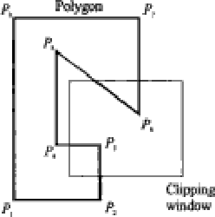

1. right head corner is at R(2,6).Apply the Cohen Sutherland Line Clipping Algorithm to find the region codes for the endpoints A(-4,2), B(-1,7), C(-1,5), D(3,8), G(1,-2), H(3,3) and I(- 4,7).
2. Given radius r=10 determine positions along the circle octants in 1st Quadrant from x=0 to x=y.
3. Outline and explain the various applications of Computer Graphics.

Computer graphics is a vast field with a wide range of applications. Some of the most common applications include:

* Animation: Computer graphics is used to create animations for movies, television, video games, and other media.
* Simulation: Computer graphics is used to create simulations of real-world phenomena, such as flight simulators, weather forecasting systems, and medical imaging systems.
* Visualization: Computer graphics is used to create visualizations of data, such as charts, graphs, and maps.
* Art: Computer graphics is used to create art, such as paintings, sculptures, and animations.
* Entertainment: Computer graphics is used to create entertainment, such as movies, video games, and television shows.

Computer graphics is a rapidly growing field with new applications being developed all the time. As technology continues to advance, computer graphics will become even more powerful and versatile.

Here are some additional details about the various applications of computer graphics:

* Animation: Computer animation is the process of creating moving images using computer graphics. It is used in a wide variety of applications, including movies, television, video games, and advertising.
* Simulation: Computer simulation is the use of computer models to simulate real-world systems. It is used in a wide variety of applications, including flight training, weather forecasting, and medical research.
* Visualization: Computer visualization is the process of creating images or videos to represent data. It is used in a wide variety of applications, including scientific research, business intelligence, and education.
* Art: Computer art is the use of computer graphics to create art. It is a broad field that includes a wide variety of styles and techniques.
* Entertainment: Computer graphics is used to create entertainment in a wide variety of forms, including movies, video games, and television shows. Computer graphics has made it possible to create realistic and immersive worlds that can be enjoyed by people of all ages.

1. Rotate a triangle ABC with vertices A(2, 3, 1), B(3, 4, 5) and C(5, 6, 7) about the Y axis
2. Analyse the different 3 D Transformations and its types. Also Discover their transformation matrices and equations.
3. A polygon has four vertices locate at A(20, 10), B(60, 10) C(60, 30) and D(20, 30). Solve and discover the vertices after Applying a scaling transformation to double the size of polygon with point A located on the same place.
4. Apply Sutherland Hodgeman Polygon Clipping Algorithm to Clip the given polygon.

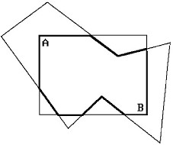

1. Perform a 45 degree rotation of triangle A(0, 0), B(1, 1), C(5, 2) followed by twice magnification about P(-1, -1)
2. Explain the general pivot point rotation

general pivot point rotation is a type of transformation in computer graphics that rotates an object around a specified pivot point. The pivot point can be any point in the object's local coordinate system. The rotation angle can be any value in degrees.

To perform a general pivot point rotation, the following steps are typically used:

1. Translate the object so that the pivot point is at the origin.
2. Rotate the object around the origin by the specified angle.
3. Translate the object back to its original position.

General pivot point rotation can be used to create a variety of effects, such as rotating a character's head to look at something, or rotating a car's wheels to turn. It is a powerful tool that can be used to add realism and animation to computer graphics.

1. Discover and analyse the window to viewport normalization Transformation, that maps a window whose lower left corner is at (1,1) and upper right corner is at (3,5) onto a viewport that has lower left corner at (0,0) and upper right corner at (1/2,1/2).
2. Explain about composite transformation in general

Composite transformation is a mathematical operation that combines two or more transformations into a single transformation. This is often used in computer graphics to create complex geometric shapes and animations.

The most common type of composite transformation is a sequence of translations, rotations, and scalings. For example, a composite transformation could be used to move an object to a new location, rotate it by a certain angle, and scale it by a certain factor.

Composite transformations can also be used to combine more complex operations, such as shearing and perspective projections. This makes them a powerful tool for creating realistic and engaging graphics.

Here is an example of how composite transformation can be used to create a complex geometric shape:

1. Start with a simple shape, such as a square.
2. Translate the square to a new location.
3. Rotate the square by a certain angle.
4. Scale the square by a certain factor.
5. The result is a complex geometric shape that was created by combining multiple transformations.

Composite transformations can also be used to create animations. For example, a composite transformation could be used to move an object across the screen, rotate it around its axis, or scale it up and down.

Here is an example of how composite transformation can be used to create an animation:

1. Start with an object in a starting position.
2. Apply a composite transformation to the object to move it to a new position.
3. Repeat step 2 for a certain number of frames.
4. The result is an animation that shows the object moving from its starting position to its new position.

Composite transformations are a powerful tool that can be used to create complex geometric shapes and animations. They are often used in computer graphics to create realistic and engaging graphics.

1. "Write short notes.
   1. Ambient light
   2. Diffuse reflection
   3. Specular reflection
   4. Intensity Attenuation

## e. Transparency and Shadows"

**Ambient Light**

Ambient light is a type of light that is evenly distributed throughout a scene. It is often used to simulate the effect of indirect light, such as light that is reflected off of walls or ceilings. Ambient light is typically represented by a single color and intensity value.

**Diffuse Reflection**

Diffuse reflection is a type of reflection in which light is scattered in all directions when it hits a surface. This type of reflection is responsible for the matte appearance of many materials, such as paper, cloth, and skin. The amount of diffuse reflection that occurs at a surface is determined by the surface's roughness. Rougher surfaces scatter light more than smooth surfaces.

**Specular Reflection**

Specular reflection is a type of reflection in which light is reflected in a single direction, like a mirror. This type of reflection is responsible for the shiny appearance of many materials, such as metal and glass. The amount of specular reflection that occurs at a surface is determined by the surface's reflectivity. More reflective surfaces reflect more light.

**Intensity Attenuation**

Intensity attenuation is the decrease in light intensity over distance. This is due to the fact that light is absorbed and scattered by the atmosphere and other objects. The amount of intensity attenuation that occurs depends on the distance between the light source and the object, the type of light source, and the properties of the intervening medium.

**Color Consideration**

The color of an object is determined by the way that it reflects light. Different materials reflect different wavelengths of light, which is why we see different colors. The color of an object can also be affected by the ambient light and the shadows that are cast on it.

**Transparency and Shadows**

Transparency is the ability of an object to allow light to pass through it. Transparent objects appear to be see-through, while translucent objects allow some light to pass through, but not all. Shadows are areas of darkness that are created when an object blocks light. Shadows can be cast by opaque objects, translucent objects, and even transparent objects.

1. Distinguish 3 D Projection and its types with the help of neat diagrams in detail.

types of 3D projections, along with diagrams to illustrate them:

* Perspective projection: This is the most common type of 3D projection, and it is the one that most closely resembles how humans see the world. In a perspective projection, parallel lines appear to converge at a vanishing point, which creates the illusion of depth. [Diagram of Perspective projection]
* Parallel projection: In a parallel projection, parallel lines remain parallel, and there is no illusion of depth. Parallel projections are often used in technical drawings and CAD applications. [Diagram of Parallel projection]
* Oblique projection: An oblique projection is a type of parallel projection in which the projection lines are not perpendicular to the projection plane. This type of projection can be used to create a more dramatic sense of depth than a parallel projection. [Diagram of Oblique projection]
* Axonometric projection: An axonometric projection is a type of oblique projection in which the projection lines are at equal angles to the projection plane. This type of projection is often used in architectural drawings and engineering drawings. [Diagram of Axonometric projection]

Each type of 3D projection has its own advantages and disadvantages. Perspective projections are the most realistic, but they can be difficult to create and can distort the size and shape of objects. Parallel projections are easier to create and do not distort the size and shape of objects, but they can lack the realism of perspective projections. Oblique projections can be used to create a more dramatic sense of depth than parallel projections, but they can also be difficult to create and can distort the size and shape of objects. Axonometric projections are the easiest to create and do not distort the size and shape of objects, but they can lack the realism of perspective projections.

The best type of 3D projection to use depends on the specific application. For example, perspective projections are often used in video games and movies, while parallel projections are often used in technical drawings and CAD applications.

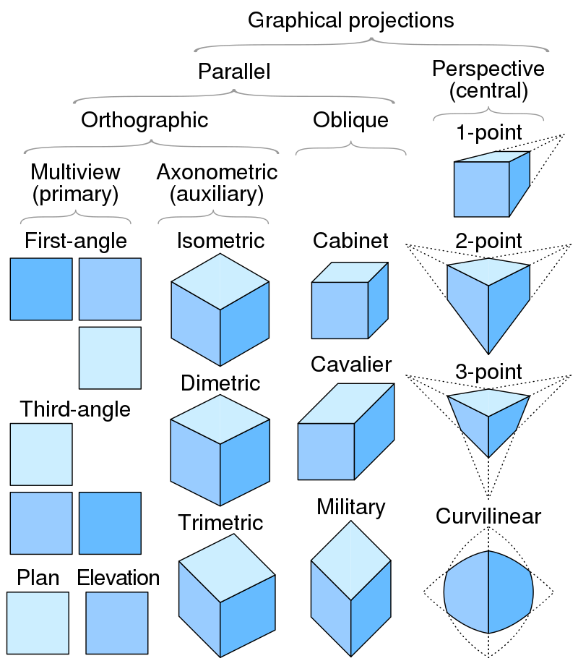

1. Apply Sutherland Hodgeman Polygon Clipping Algorithm to Clip the given polygon.

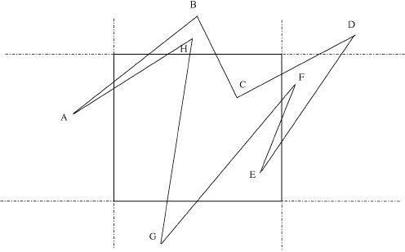

1. Define Pixel and explain how it’s different from a Point.

A pixel is the smallest addressable element in a digital image or raster image. Pixels are represented by a grid of tiny dots that are used to create the image. The number of pixels in an image is called its resolution.

A point is a unit of measurement equal to 1/72 of an inch. Points are used to measure the size of fonts and other objects on a screen.

The main difference between pixels and points is that pixels are physical units, while points are abstract units. Pixels are the smallest physical units on a screen, while points are used to measure the size of objects that are not necessarily made up of pixels.

For example, a font that is 12 points in size will always be 12 points in size, regardless of the screen resolution. However, a 12-pixel image will appear larger on a high-resolution screen than on a low-resolution screen.

Here is a table that summarizes the key differences between pixels and points:

|  |  |  |
| --- | --- | --- |
| Feature | Pixel | Point |
| Physical unit | Yes | No |
| Used to measure | Screen resolution and individual pixels | Font size and other objects |
| Always the same size | No | Yes |

1. Given a clipping window A(20, 20), B(60, 20), C(60, 40) and D(20, 40), apply Cohen Sutherland Line Clipping algorithm and solve to find the visible portion of the line segment joining the point P(40, 80) and Q(120, 30).
2. Provide the definition for homogeneous coordinates. Mention the role that they play while doing composite transformations?

In mathematics, homogeneous coordinates or projective coordinates are a system of coordinates used in projective geometry, just as Cartesian coordinates are used in Euclidean geometry. They have the advantage that the coordinates of points, including points at infinity, can be represented using finite coordinates.

Homogeneous coordinates are defined as follows:

* A point in the Euclidean plane can be represented by a triple of numbers (x, y, w), where x and y are the usual coordinates of the point and w is any non-zero real number.
* The point at infinity corresponding to the direction (numerically given by the slope of a line), informally defined as the limit of a point that moves in that direction away from the origin. Parallel lines in the Euclidean plane are said to intersect at a point at infinity corresponding to their common direction.

Homogeneous coordinates are used in computer graphics to represent points, lines, and planes. They are also used to represent transformations, such as rotations, translations, and scalings.

When performing composite transformations, homogeneous coordinates are used to ensure that the results are well-defined. For example, if a point is translated and then rotated, the resulting point will be in the correct position. This is because the translation and rotation are both represented as matrices, and matrices can be multiplied together to produce a new matrix.

Homogeneous coordinates are a powerful tool that can be used to represent and manipulate geometric objects. They are essential for computer graphics, and they are also used in other fields, such as physics and computer vision.

Here are some of the advantages of using homogeneous coordinates:

* They can represent points at infinity.
* They can represent parallel lines as intersecting lines.
* They can represent transformations in a way that is easy to manipulate.

Here are some of the disadvantages of using homogeneous coordinates:

* They can be difficult to understand at first.
* They can lead to numerical errors if not handled properly.

Overall, homogeneous coordinates are a powerful tool that can be used to represent and manipulate geometric objects. They are essential for computer graphics, and they are also used in other fields, such as physics and computer vision.

1. Determine the term Back Face Detection algorithm and Depth buffer method

Back Face Detection

Back face detection is a method used in computer graphics to determine which faces of a polygon are facing away from the viewer. These faces are then not drawn, which helps to improve the performance of the graphics engine and to create a more realistic scene.

There are several different algorithms for back face detection. One common algorithm is to use the z-buffer. The z-buffer is a data structure that stores the depth of each pixel in the scene. When a polygon is being drawn, its vertices are projected onto the z-buffer. If the depth of a vertex is greater than the depth of the pixel it is being projected onto, then the face is facing away from the viewer and is not drawn.

Another common algorithm for back face detection is to use the normal vector of the polygon. The normal vector is a vector that is perpendicular to the surface of the polygon. If the dot product of the normal vector and the viewing vector is negative, then the face is facing away from the viewer and is not drawn.

Depth Buffer

The depth buffer is a data structure that is used to store the depth of each pixel in a scene. The depth of a pixel is the distance from the camera to the surface that is being rendered at that pixel. The depth buffer is used to determine which pixels are in front of other pixels and to prevent objects from being rendered in front of other objects that are closer to the camera.

The depth buffer is typically implemented as a two-dimensional array of floating-point numbers. The depth buffer is updated whenever a new object is rendered. The depth of the new object is stored in the depth buffer at the location of each pixel that is covered by the object.

When the depth buffer is used to render a scene, the graphics engine first clears the depth buffer to a large value, such as infinity. Then, the graphics engine renders each object in the scene, starting with the objects that are closest to the camera and working its way back. As each object is rendered, the graphics engine updates the depth buffer with the depth of the object at each pixel that is covered by the object.

The depth buffer is a very important data structure in computer graphics. It is used to prevent objects from being rendered in front of other objects that are closer to the camera. This helps to create a more realistic scene and to avoid z-fighting, which is an artifact that can occur when two objects are rendered in the same location.

1. Elaborate depth buffer algorithm for hidden surface removal in three dimensional objects.

steps involved in the depth buffer algorithm for hidden surface removal in three dimensional objects:

1. Clear the depth buffer to a large value, such as infinity. This will ensure that no pixels are drawn at the start.
2. For each object in the scene:
   * Project the object onto the screen. This will convert the object's 3D coordinates into 2D coordinates on the screen.
   * For each pixel that is covered by the object:
     + Read the depth value from the depth buffer at that pixel.
     + If the depth value of the object is less than or equal to the depth value in the depth buffer, then draw the object at that pixel.
     + Otherwise, do not draw the object at that pixel.

This algorithm works by storing the depth of each pixel in the depth buffer. When an object is projected onto the screen, its vertices are compared to the depth values in the depth buffer. If the depth of a vertex is less than or equal to the depth value in the depth buffer, then the object is drawn at that pixel. Otherwise, the object is not drawn at that pixel.

The depth buffer algorithm is a very simple and efficient algorithm for hidden surface removal. It is often used in real-time graphics applications, such as video games and 3D modeling software.

Here are some of the advantages of the depth buffer algorithm:

* It is simple and efficient.
* It can be used in real-time graphics applications.
* It can handle a wide variety of objects and scenes.

Here are some of the disadvantages of the depth buffer algorithm:

* It can produce z-fighting artifacts.
* It can be difficult to implement for complex scenes.
* It does not take into account other factors, such as lighting and shadows.

Overall, the depth buffer algorithm is a simple and efficient algorithm for hidden surface removal. It is often used in real-time graphics applications, but it can also be used for more complex scenes.

1. Explain Video Controller.

**Video controller :-**

1. Video controller is a key hardware component that allows computers to generate graphic information to any video display devices, such as a monitor or projector.
2. They are also known as graphics or video adapters that are directly integrated into the computer motherboard.
3. Their main function as an integrated circuit in a video signal generator is to produce television video signals in computers systems.
4. They also offer various functions beyond accelerated image rendering, such as TV output and the ability to hook up to several monitors.
5. Write short notes on Blobby Objects, Polygon Tables, 3 D Primitives, Polygon Meshes, Word Coordinates, Device Coordinates, Normalized Coordinates, Window, Viewport.

* Blobby Objects: Blobby objects are a type of 3D object that is created by using a mathematical function to generate the object's shape. Blobby objects are often used in computer graphics applications, such as video games and 3D modeling software.
* Polygon Tables: Polygon tables are a data structure that is used to store information about polygons. Polygon tables typically store the vertices, edges, and faces of a polygon. Polygon tables are often used in computer graphics applications, such as rendering and collision detection.
* 3D Primitives: 3D primitives are basic shapes that can be used to create more complex 3D objects. Common 3D primitives include cubes, spheres, and cylinders. 3D primitives are often used in computer graphics applications, such as modeling and animation.
* Polygon Meshes: Polygon meshes are a type of 3D object that is made up of a collection of polygons. Polygon meshes are often used in computer graphics applications, such as video games and 3D modeling software.
* World Coordinates: World coordinates are the coordinates of a point in the real world. World coordinates are typically used to represent the positions of objects in a 3D scene.
* Device Coordinates: Device coordinates are the coordinates of a point on a display device, such as a monitor. Device coordinates are typically used to represent the positions of pixels on a screen.
* Normalized Coordinates: Normalized coordinates are coordinates that are normalized to a range of [0, 1]. Normalized coordinates are often used in computer graphics applications, such as rendering and texture mapping.
* Window: The window is the rectangular area of a display device that is used to display a 3D scene.
* Viewport: The viewport is the rectangular area of a 3D scene that is visible in the window.

1. Determine the 3D transformation matrices to translate a line PQ in the x direction by 3, y direction by 2 and z direction by 2